## horizontal line



Functionality Specification Document

----------------------------------------------------------------------------------------------------------------------------

**Document Version 1.0**

**19 - June - 2021**

**Author : Shivani Maski**

**CI/CD Deployment for Springboot Application**

**Content**

**1 . About this Document……………………………............2**

**1.1 How this Document is organized ……………………………………………………….. 2**

**1.2 Contact Information ……………………………………………………………………. 3**

**2 . Introduction……………………………………………...4**

**2.1 Objectives…………………………………………………………………….………........4**

**3 . Flow Chart……………………………………………......5**

**2.1 Flow Chart…………………………………………………………………….………...... 5**

**4 . Solution Overview………………………………………..7**

**3.1 User Interfaces …………………………………………………………………………. …7**

**5 . Github link……………………………………………......9**



1. **About this Document**

**This functional and integration (FIS) document will enable you to understand the proposed solution for the creation of Deployment for Springboot Application.**

**The content of the document will have a solution and its configuration details as it will be available for our client.**

**1.1 How this Document is organized**

**This document is organized into the following chapters:**

**Chapter 2 - "Introduction" provides solution scope to be delivered to our Client.**

**Chapter 3 - "Flow Chart" explains the execution of flow of the Ap**

**Chapter 4 - "Solution Overview" provides how the solution of the project is .**

**Chapter 5- “Github link” provides the information on where the project is located.**



**2 . Introduction**

**This document describes the implementation of Deployment for Springboot Application and how its users can interact with the application.**

**2.1 Objectives**

**The objective of this document is to describe how Deployment for Springboot Application is done and how user will integrate with it.**

**This document also provides information on end-to-end workflow flow so that business users can understand the Deployment for Springboot Application *.***

**The workflow mainly involves the following important aspects,**

1. **Creation of Amazonec2 instance**
2. **Creating a docker container.**

**========================================================================**

**4 Solution Overview**

**Platform requirement**

**The platform used for this project is the angular, node js, VS code.**

**5.1. UI for User:-**

**Below is the welcome page of the application**

**=====================================================================**

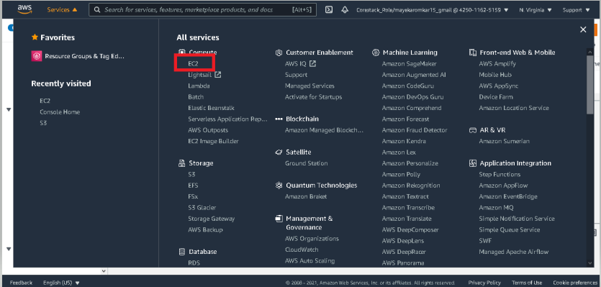

**========================================================================**

**Step 1:- The above page is displayed for the user to solve the question and answers.**

**----------------------------------------------------------------------------------------------------------------------------**

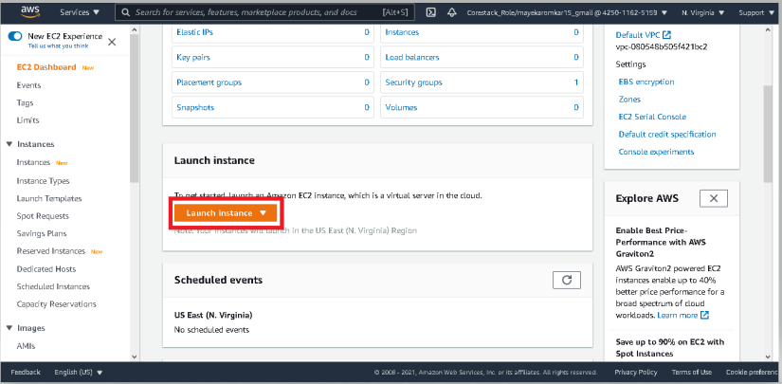

**Step 2  - After completion of the quiz the following page is displayed.**

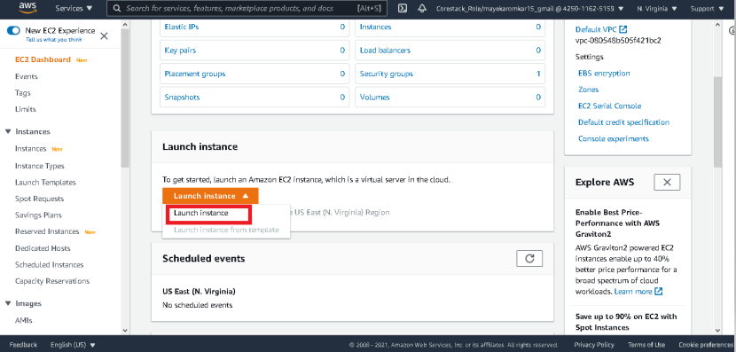

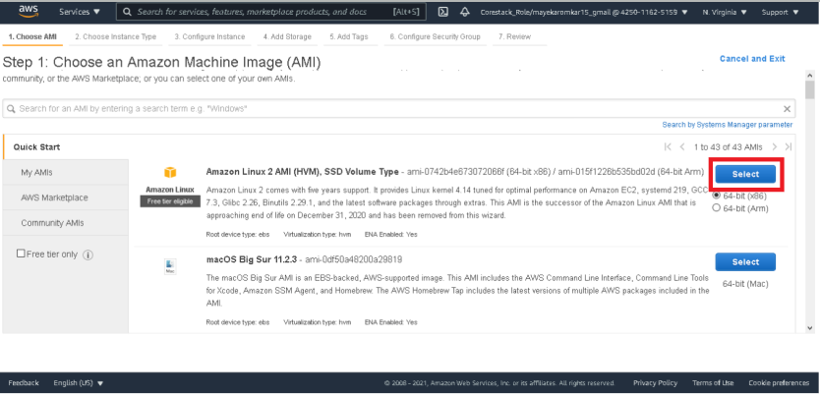

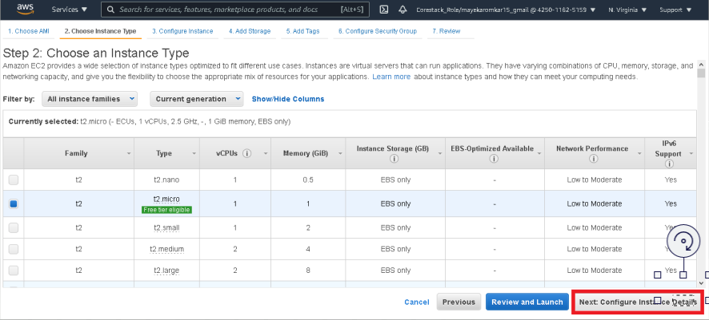

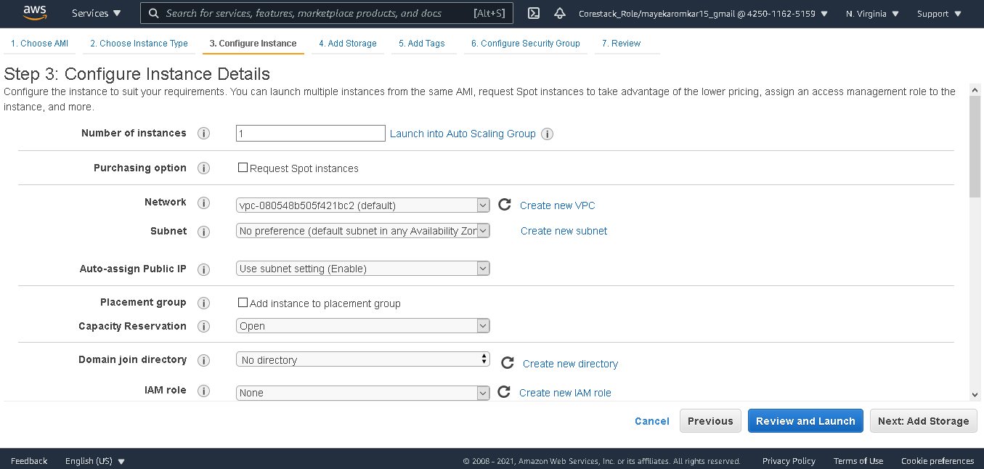

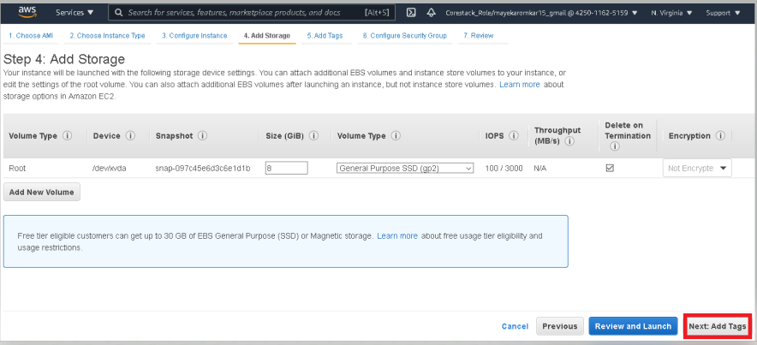

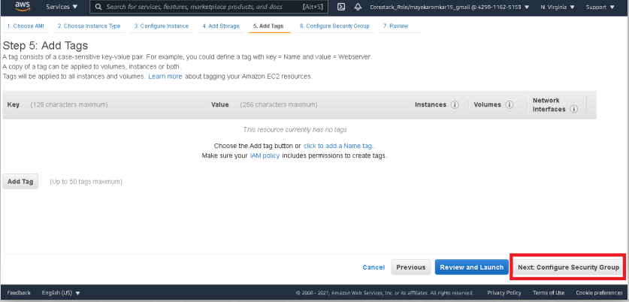

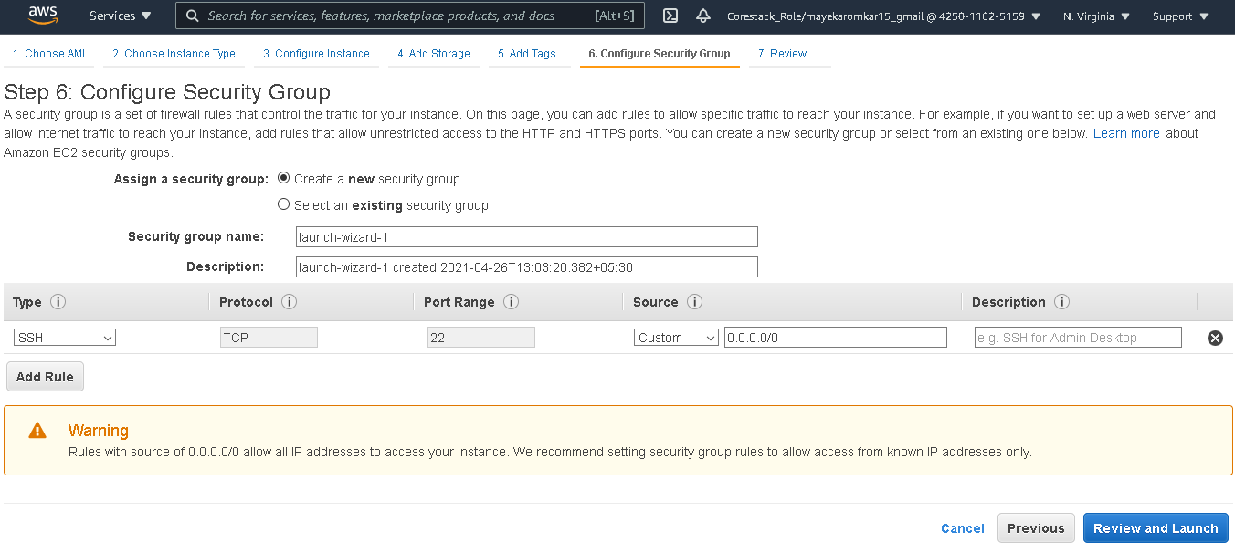

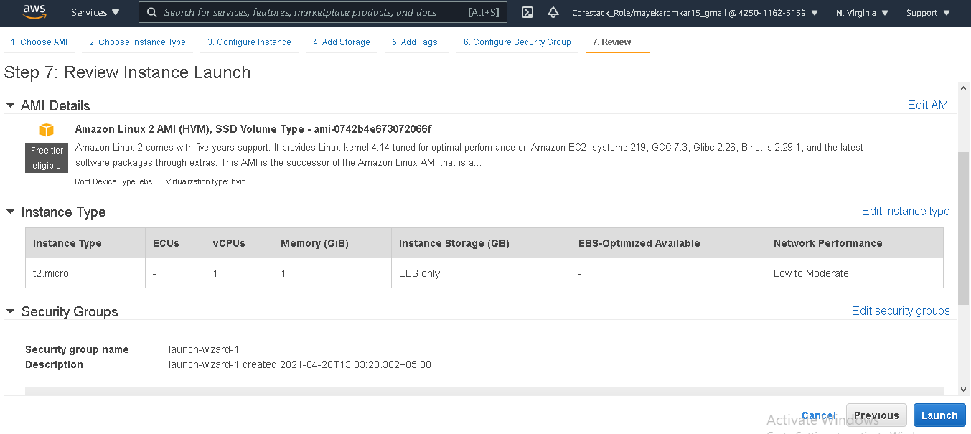

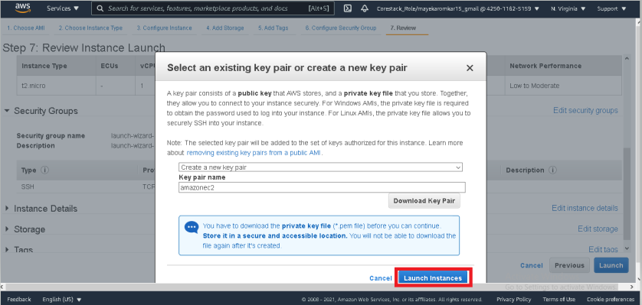

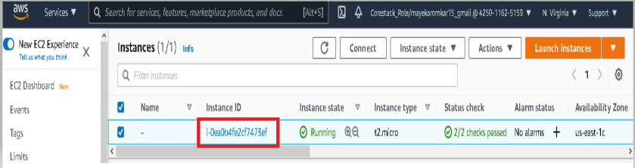

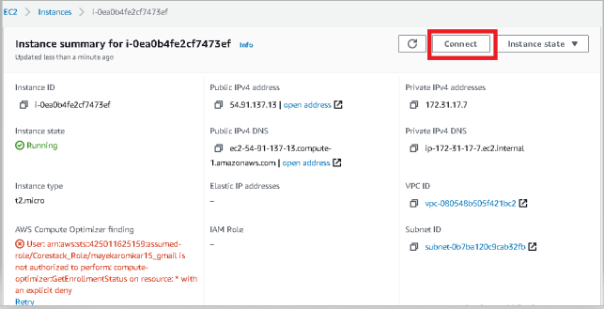

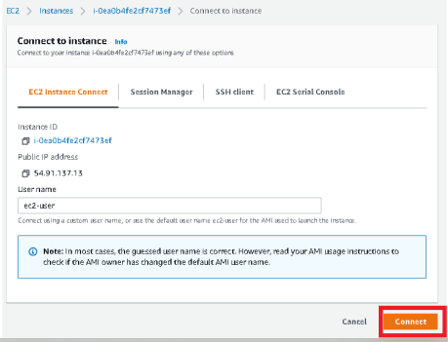

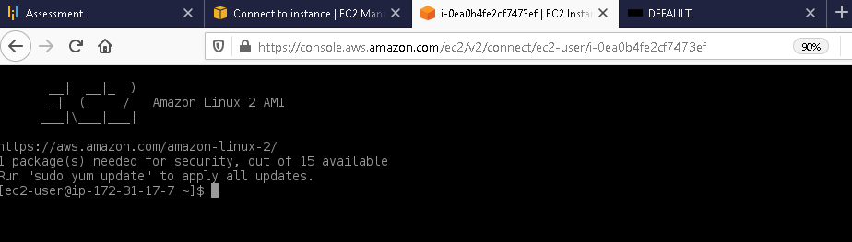

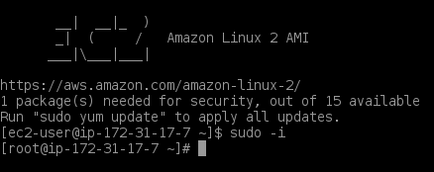

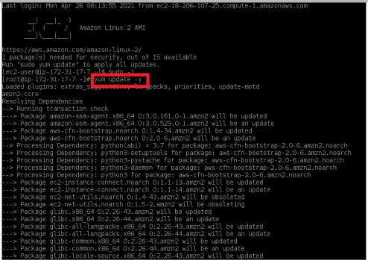

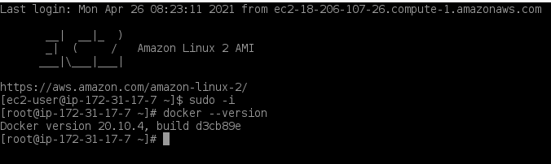

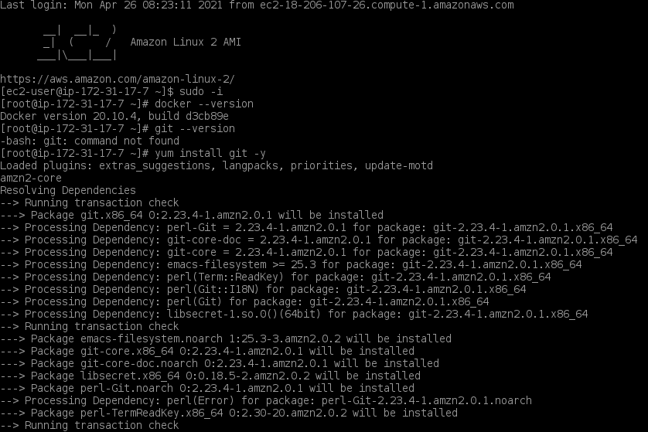

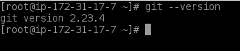

Cloning the project

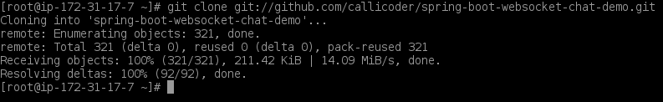



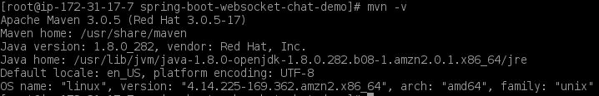





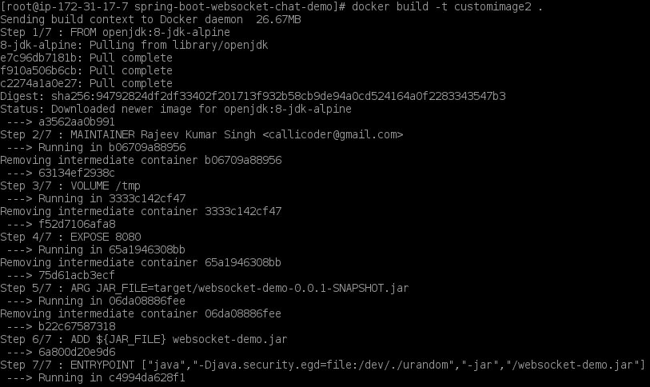



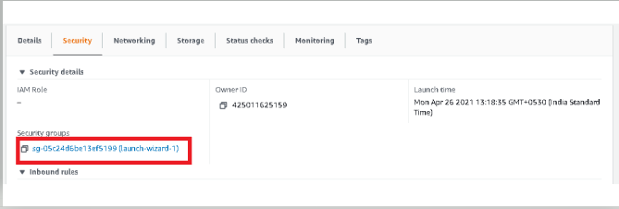

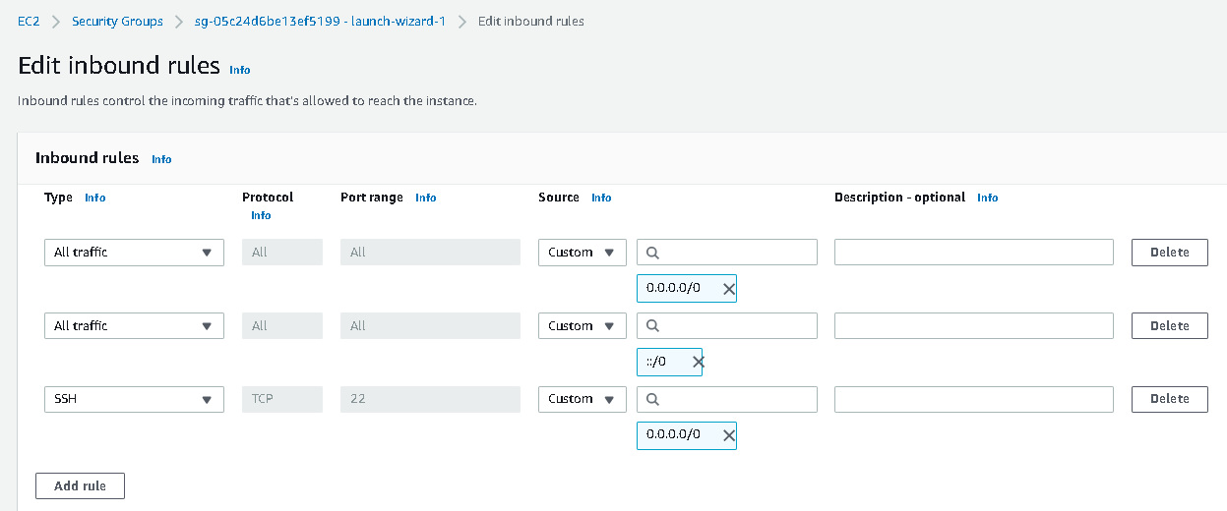

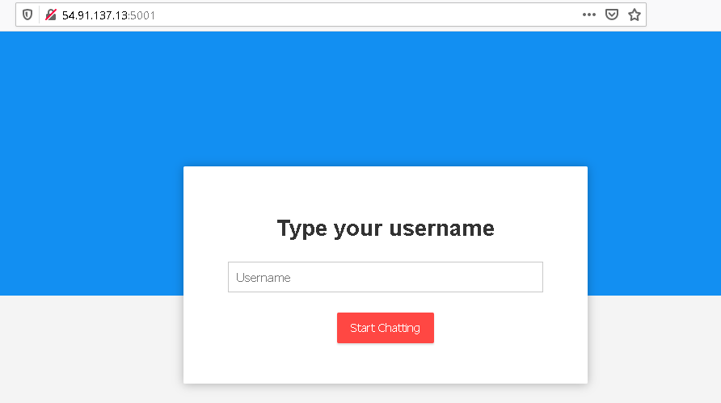

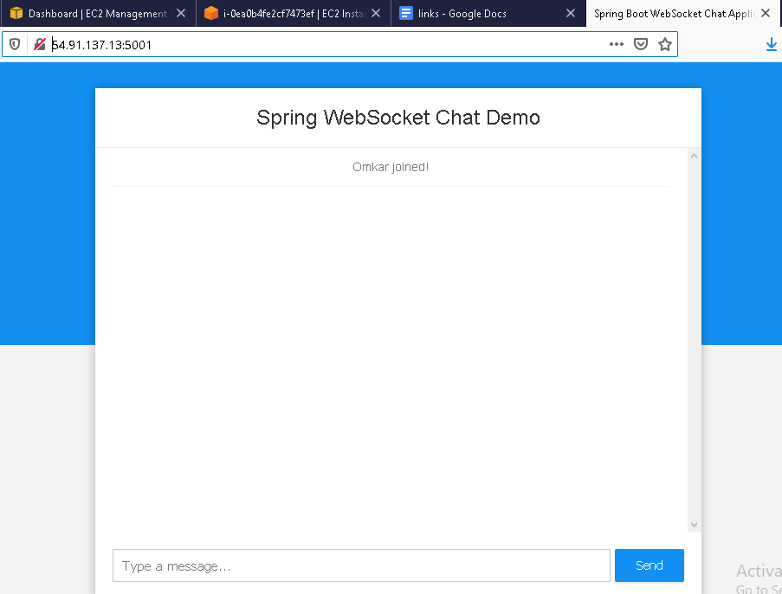

**.**

**5. Github link**

**This section lists where the source code is located and from where the user can download and use it.**

<https://github.com/sm35937/Onlinequizportal>